**Pooja Bahuguna**

**4085**

**1.Git Setup** [**https://confluence.atlassian.com/bitbucket/set-up-git-744723531.html**](https://confluence.atlassian.com/bitbucket/set-up-git-744723531.html)

[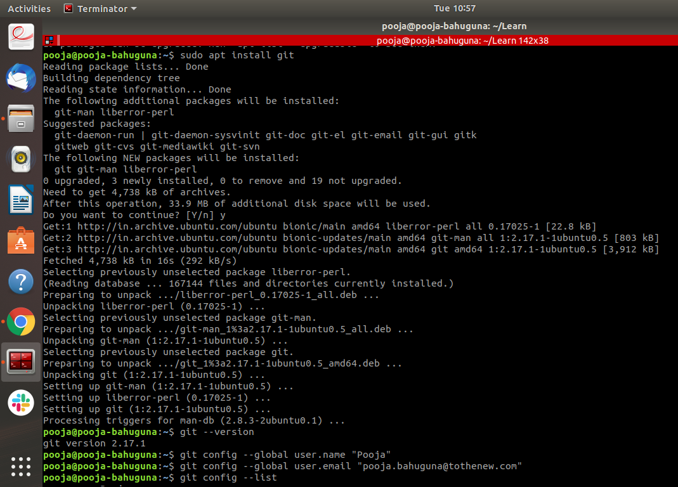](https://confluence.atlassian.com/bitbucket/set-up-git-744723531.html)



**2.Initialize a Git Repository**

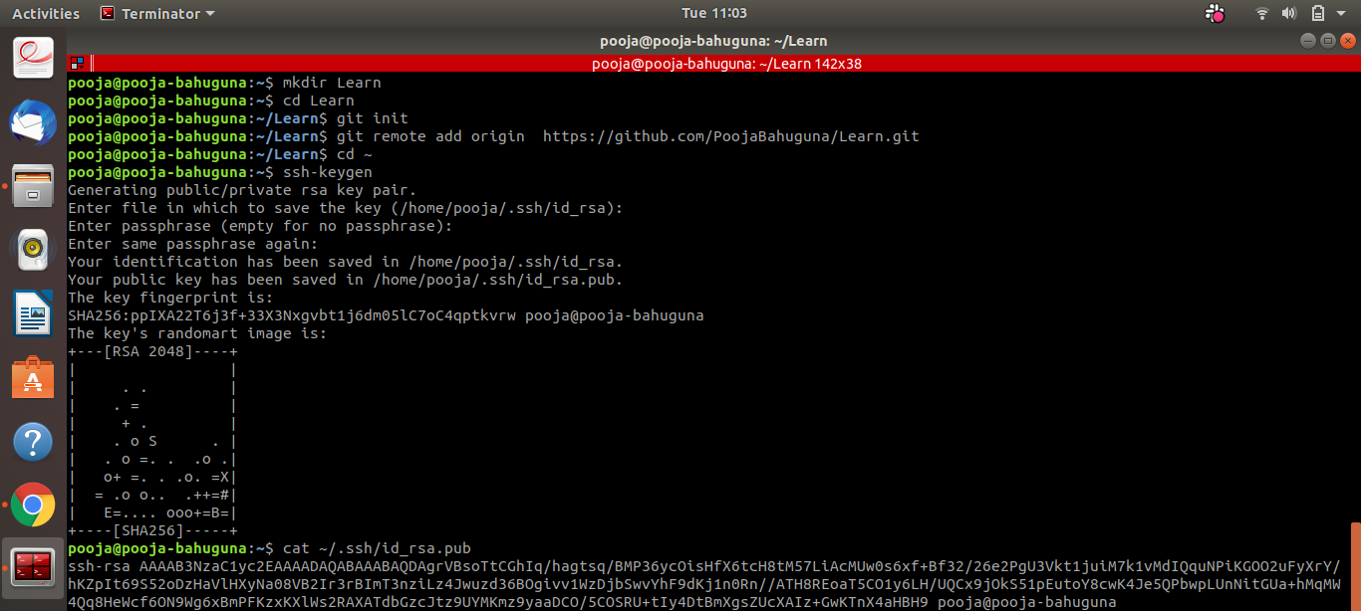

**3.Add files to the repository**

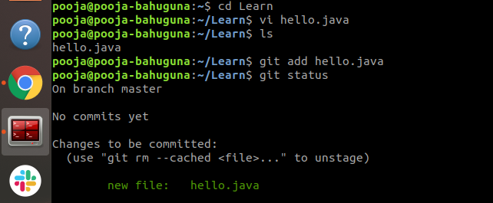

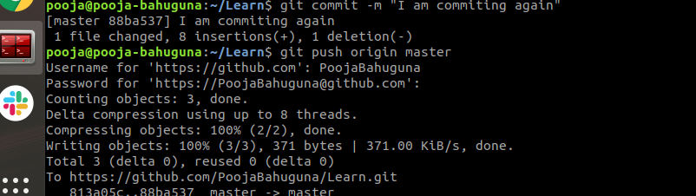

**4.Unstage 1 file**

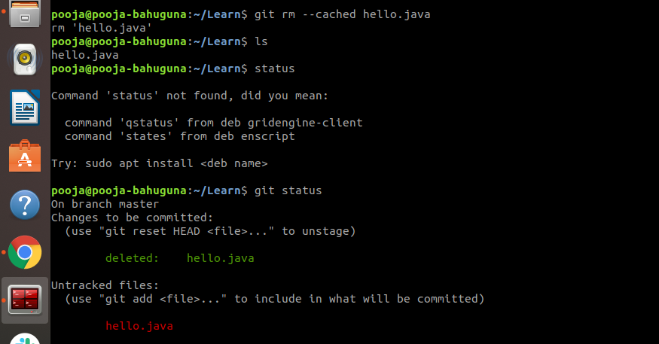

**5.Commit the file**

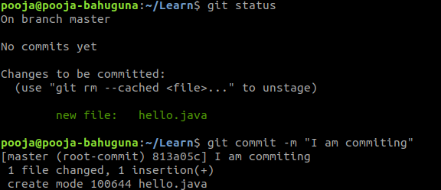

**6.Add a remote**



**7.Undo changes to a particular file**

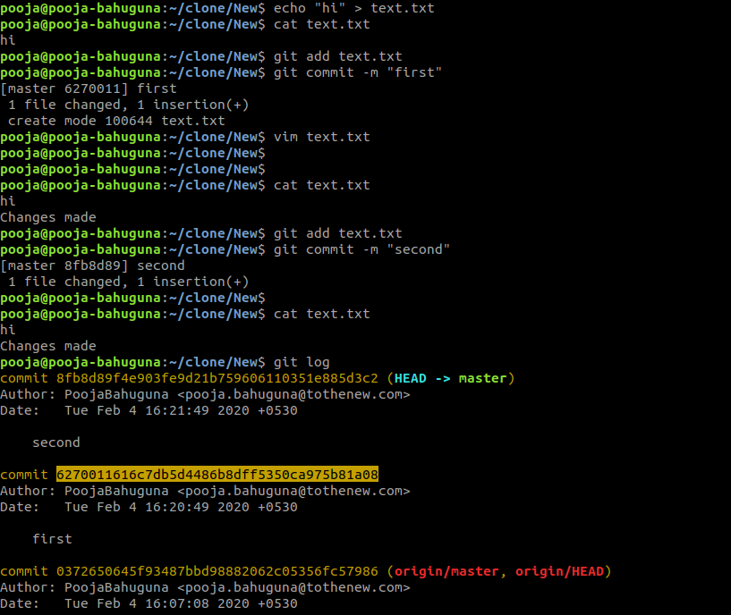

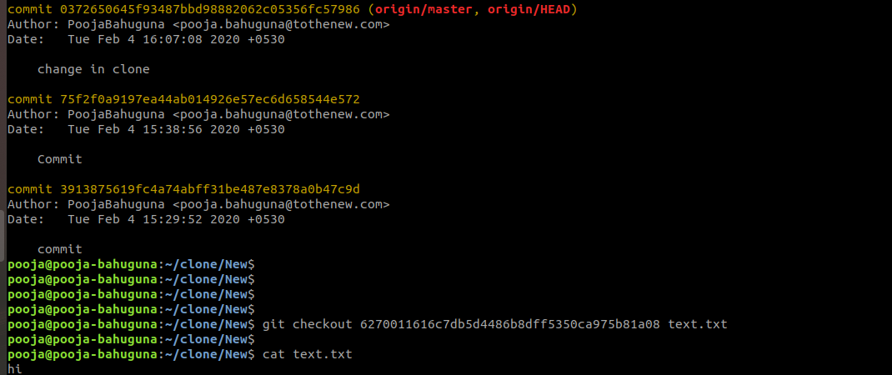

**8.Push changes to Github**

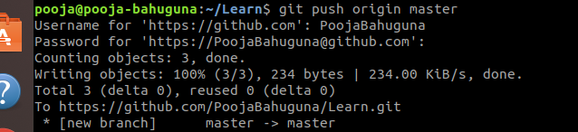

**9.Clone the repository**

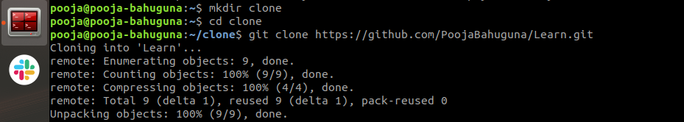

**10.Add changes to one of the copies and pull the changes in the other.**

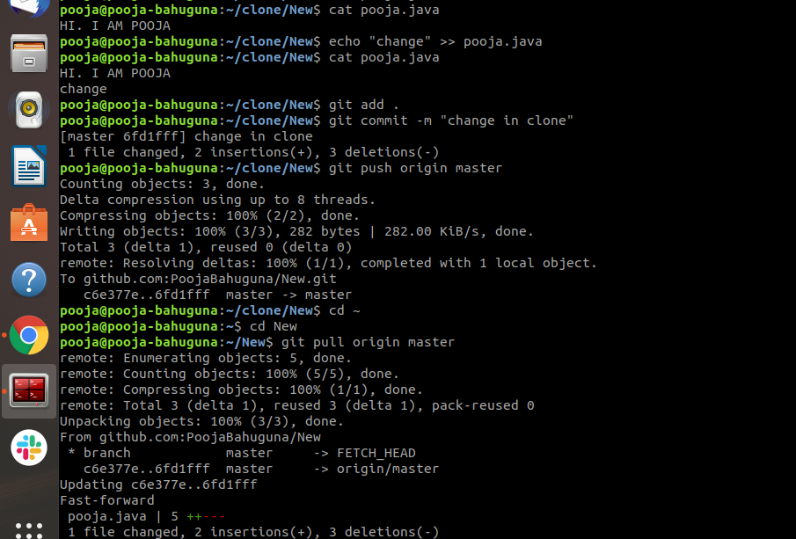

**11.Check differences between a file and its staged version**

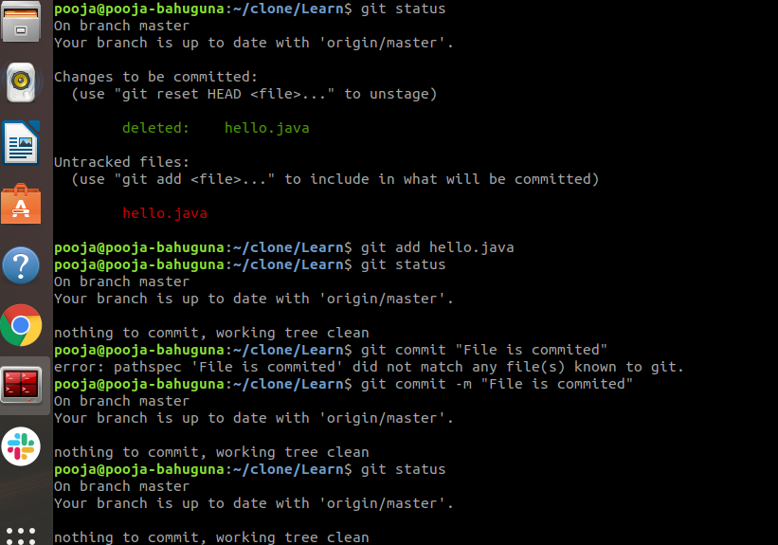

**12.Ignore a few files to be checked in**

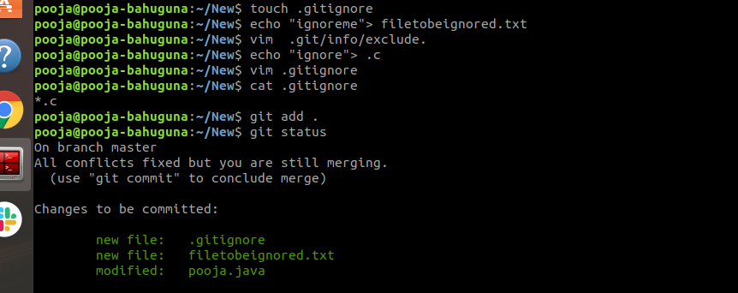

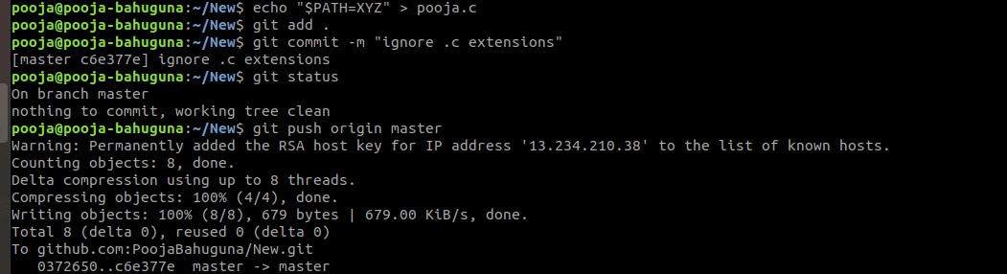

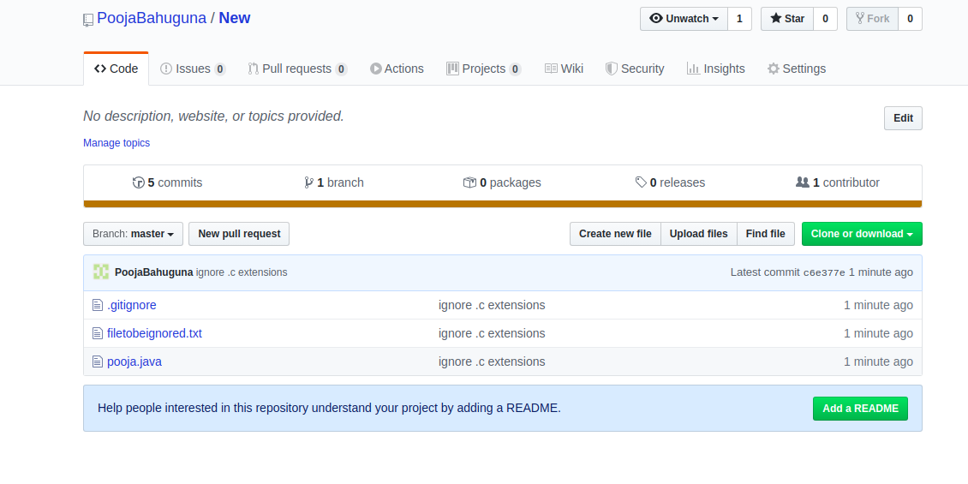

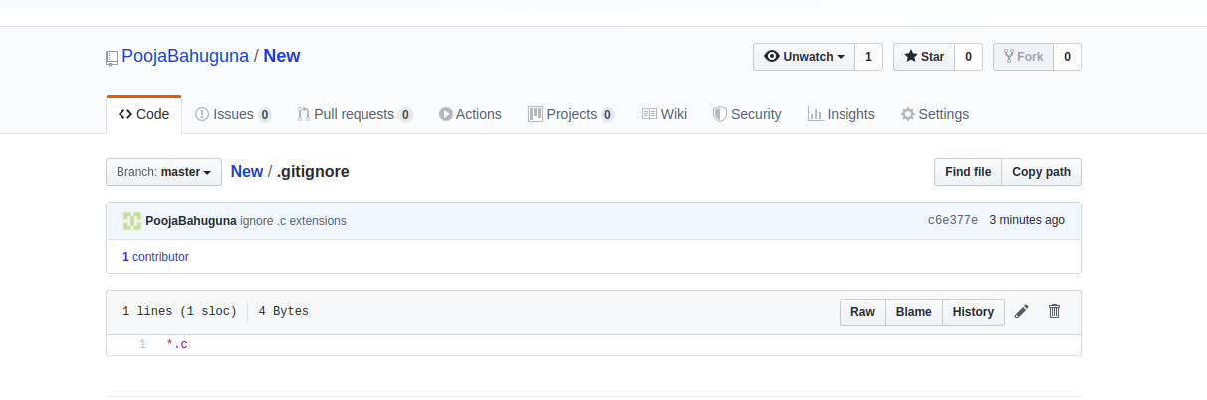

**13.Create a new branch.**

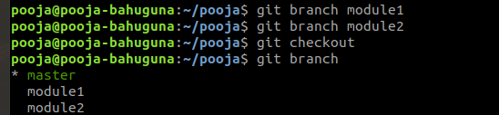

**14.Diverge them with commits**

**15.Edit the same file at the same line on both branches and commit**

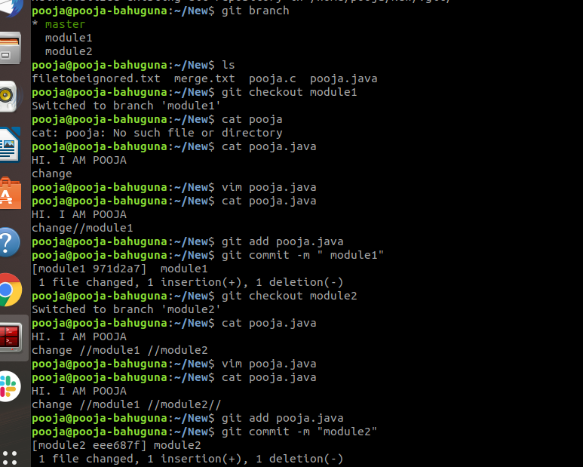

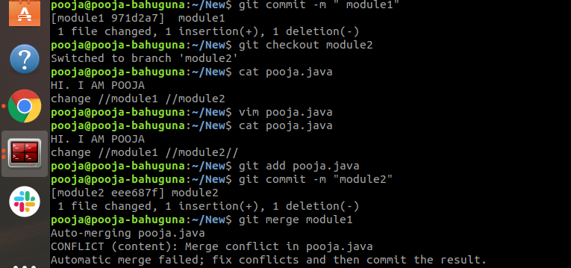

**16.Try merging and resolve merge conflicts**

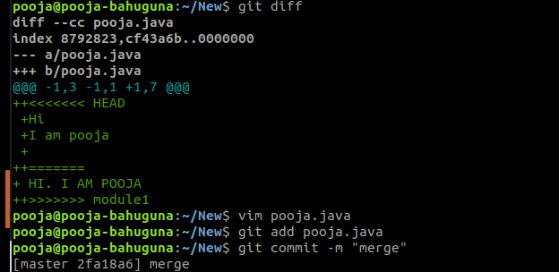

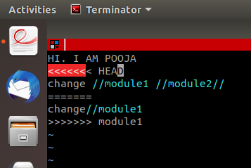

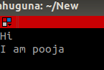

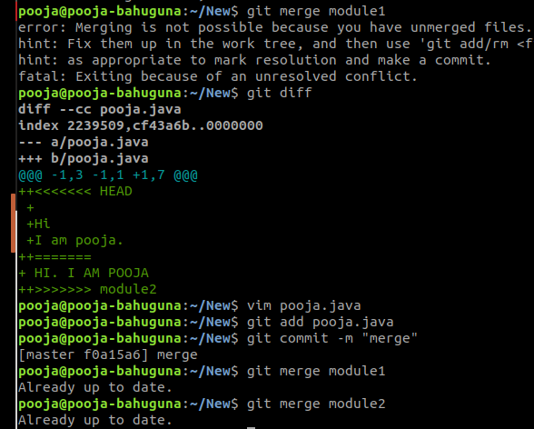

**17.Stash the changes and pop them**

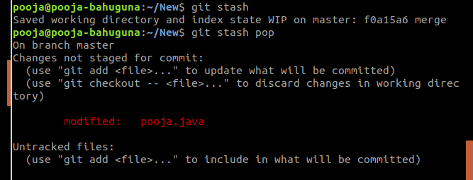

**18.Add the following code to your .bashrc file :**

**color_prompt="yes"  
parse_git_branch() {  
git branch 2> /dev/null | sed -e '/^[^*]/d' -e 's/* \(.*\)/(\1)/'  
}  
if [ "$color_prompt" = yes ]; then  
PS1='\u@\h\[\033[00m\]:\[\033[01;34m\]\W\[\033[01;31m\] $(parse_git_branch)\[\033[00m\]\$ '  
else  
PS1='\u@\h:\W $(parse_git_branch)\$ '  
fi  
unset color_prompt force_color_prompt**



